Revit Family API Labs
Lab4 – Add Visibility Control
June 15, 2009 by MH
Last modified: July 30, 2009 by JT
VB.NET version
Objective: In this lab, we will learn how to:
- add visibility control
Tasks: We’ll extend the command we have defined in the previous labs and add visibility control. We’ll add a line presentation of the column for the coarse view.
- Take the command class which we have defined in the Lab3. This will be the starting point of this lab. We’ll continue using the Family Editor and "Metric Column.rft" template.
- Define line representations for a column:
  - Single lined symbolic-line representation in a plan view
  - Single lined model-line representation in a model view
- Sett the visibility control so that we single line representation is used when coarse view is chosen.
Figure 1 shows the image of the graphical representation in Medium/Fine and Coarse detail level.
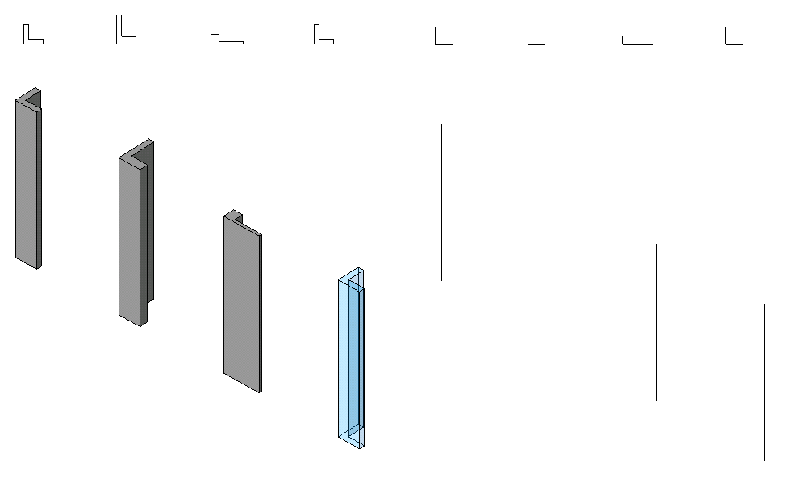
Figure1 Representation of a column: a column is represented with
lines in Coarse detail level and a solid in Medium and Fine.

The following is the breakdown of step by step instructions in this lab:
- Define Another External Command
- Add Line Objects for Coarse Level
- Change the Visibility of the Solid
- Test Your Column

- Define Another External Command
We’ll be extending the command we have defined in Lab3. You can either copy it to define a new class or continue extending the existing one on top of it. (Just make sure to back up in case you need it to start again.)
  - Copy the command class from Lab3 and define a new one to work on in Lab3. Let’s name them as:
- File name: 4 FamilyCreateColumnVisibility.vb (or .cs)
- Command class name: RvtCmd_FamilyCreateColumnVisibility

(Once again, you may choose to use any names you want here. When you do so, just remember what you are calling your own project, and substitute these names as needed while reading the instruction in this document.)
Public Class RvtCmd_FamilyCreateColumnVisibility
...

End Class

2. Add Line Objects for Coarse Level
We are going to add simple line representations for a column. We then set their visibilities to coarse level :
- Two symbolic lines in an L-shape. They will be visible in the top view only.
- A vertical model line. This will be visible for a 3D view.
2.1 Add the following function to the class:
'' ============================================
'' (5.1.1) create simple line objects to be displayed in coarse level
'' ============================================
Sub addLineObjects()

''
'' define a simple L-shape detail line object
''
'' 0
'' + h = height
'' | (we also want to draw a vertical line here at point 1)
'' d |
'' +-----+
'' 1 2
'' w
''

'' sizes
Dim w As Double = mmToFeet(600) '' modified to match reference plane. otherwise, alignment won't work.
Dim d As Double = mmToFeet(600)
Dim h As Double = mmToFeet(4000) '' distance between Lower and Upper Ref Level.
Dim t As Double = mmToFeet(50) '' slight offset for visbility

'' define vertices
''
Dim pts() As XYZ = {New XYZ(-w / 2 + t, d / 2, 0), New XYZ(-w / 2 + t, -d / 2 + t, 0), New XYZ(w / 2, -d / 2 + t, 0)}
Dim ptH As XYZ = New XYZ(-w / 2 + t, -d / 2 + t, h) ' this is for vertical line.

''
'' (2) create a sketch plane
''
'' we need to know the template. If you look at the template (Metric Column.rft) and "Front" view,
'' you will see "Reference Plane" at "Lower Ref. Level". We are going to create an extrusion there.
'' findElement() is a helper function that find an element of the given type and name. see below.
'' Note: we did the same in creating a profile.
''
Dim pRefPlane As ReferencePlane = findElement(GetType(ReferencePlane), "Reference Plane") ' need to know from the template
Dim pSketchPlane As SketchPlane = _rvtDoc.FamilyCreate.NewSketchPlane(pRefPlane.Plane)

Dim pRefPlaneH As ReferencePlane = findElement(GetType(ReferencePlane), "Left") ' need to know from the template
Dim pSketchPlaneH As SketchPlane = _rvtDoc.FamilyCreate.NewSketchPlane(pRefPlaneH.Plane)

'' (4) create line objects: two symbolic curves on a plan and one model curve representing a column like a vertical stick.
''
Dim geomLine1 As Geometry.Line = _rvtApp.Create.NewLine(pts(0), pts(1), True)
Dim geomLine2 As Geometry.Line = _rvtApp.Create.NewLine(pts(1), pts(2), True)
Dim geomLineH As Geometry.Line = _rvtApp.Create.NewLine(pts(1), ptH, True)

Dim pLine1 As SymbolicCurve = _rvtDoc.FamilyCreate.NewSymbolicCurve(geomLine1, pSketchPlane)
Dim pLine2 As SymbolicCurve = _rvtDoc.FamilyCreate.NewSymbolicCurve(geomLine2, pSketchPlane)

Dim pLineH As ModelCurve = _rvtDoc.FamilyCreate.NewModelCurve(geomLineH, pSketchPlaneH) ' this is vertical line

'' set the visibilities of two lines to coarse only
''
Dim pVis As FamilyElementVisibility = New FamilyElementVisibility(FamilyElementVisibilityType.ViewSpecific)
pVis.IsShownInFine = False
pVis.IsShownInMedium = False

pLine1.SetVisibility(pVis)
pLine2.SetVisibility(pVis)

Dim pVisH As FamilyElementVisibility = New FamilyElementVisibility(FamilyElementVisibilityType.Model)
pVisH.IsShownInFine = False
pVisH.IsShownInMedium = False

pLineH.SetVisibility(pVisH)

End Sub

We start by defining the initial value of vertices used to draw lines. As always, we are hard-coding them for simplicity.
You can use Document.FamilyCreate to draw symbolic or model lines:
_rvtDoc.FamilyCreate.NewSymbolicCurve(geomLine1, pSketchPlane)
_rvtDoc.FamilyCreate.NewModelCurve(geomLineH, pSketchPlaneH)

Here is our key piece to set the visibility:
Dim pVis As FamilyElementVisibility = New FamilyElementVisibility(FamilyElementVisibilityType.ViewSpecific)
pVis.IsShownInFine = False
pVis.IsShownInMedium = False
pLine1.SetVisibility(pVis)
FamilyElementVisibility is a helper class that keeps track of the information about visibility of a specific element. It takes EamilyElementVisitlityType in the constructor, which are a type of either ViewSpecific or Model:
- ViewSpecific - The element will be displayed only in the view where it is created. This applies to items like detail components, annotations, and view-specific imports.
- Model - The element will be displayed in 3D views and model other model views.
By default, visibilities are all set as True. You can turn off by setting them False for each viewing conditions. We then set it to each element.
2.2 Call addLineObjects() function from your main command function Execute():
...

'' (4.2) add materials
''
addMaterials(pSolid)

'' (5.1) add visibilities
''
addLineObjects()

...

2.3 Your code should build and run.

3. Change the Visibility of the Solid
One last thing we need to do is turn off the visibility of the extrusion we have for L-shape solid in a coarse view.
3.1 Add the follow function to the class:
'' ============================================
'' (5.1.2) set the visibility of the solid not to show in coarse
'' ============================================
Sub changeVisibility(ByVal pSolid As Extrusion)

'' set the visibility of the model not to shown in coarse.
''
Dim pVis As FamilyElementVisibility = New FamilyElementVisibility(FamilyElementVisibilityType.Model)
pVis.IsShownInCoarse = False

pSolid.SetVisibility(pVis)

End Sub

The exact same idea as we have done for line objects earlier. Create a FamilyElementVisibility class, this time, using FamilyElementVisibilityType.Model. Set its IsShownInCoarse property as False, and set it to the solid.

4. Test Your Column
Your code is ready to build and run for testing.

You can add lines like the following to you .ini file to test this. (You can either add a new command or replace with one from Lab3.) Make necessary adjustment to match with your environment, of course.

[ExternalCommands]
ECCount=1

ECName1=Family API 4 Define Visibility
ECDescription1= Family API lab 4 to create L-shaped column with visibility settings
ECClassName1=LabsVb.RvtCmd_FamilyCreateColumnVisibility
ECAssembly1=…\LabsVB.dll

Remember to start with Family Editor and use "Metric Column.rft" template.

After running a command, examine the following:

- Do you see the symbolic line objects in the plan view? A model line in the 3D view?
- Switch visibility levels. You should see some lines grayed out in a certain view.
- Do line change when you change types? Or a level or height?
- Start a new project and load your family to it. Place your columns. Try changing view detail levels. Compare various viewing level and directions.

Congratulations!! You have completed your Family API Labs.

